Project Design Phase: Solution Architecture
Date | 22 September 2026
Team ID
Project Name
  Online Complaint Registration
Maximum Marks | 4 Marks

1. Solution Architecture Overview
Solution architecture bridges the project requirements and technical implementation. Its core objectives include:
- Identifying suitable technical solutions for online complaint registration and management.
- Defining the system structure, components, and interactions for users, agents, and administrators.
- Establishing development requirements for authentication, complaint management, assignment, tracking, and communication.
- Providing a secure and scalable MERN-based architecture for project implementation.

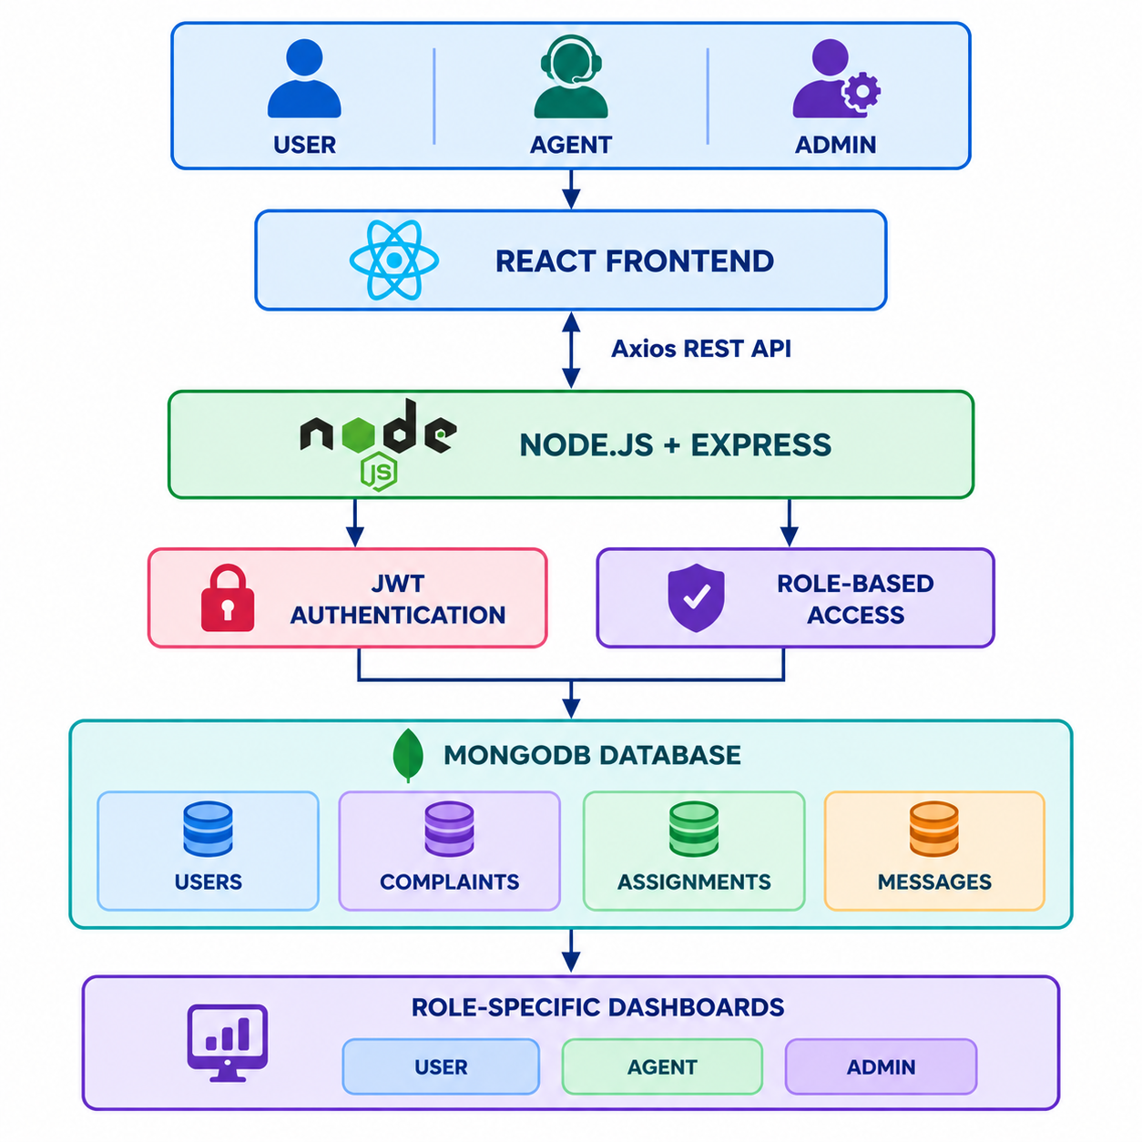
2. Proposed Solution Architecture Diagram
Figure 1: High-level MERN stack architecture flow for Online Complaint Registration and Management System

